**Web Engineering Exercise 8 – Problem 2**

**s1240234 Yuta Nemoto**

Screenshot: Creating new Article

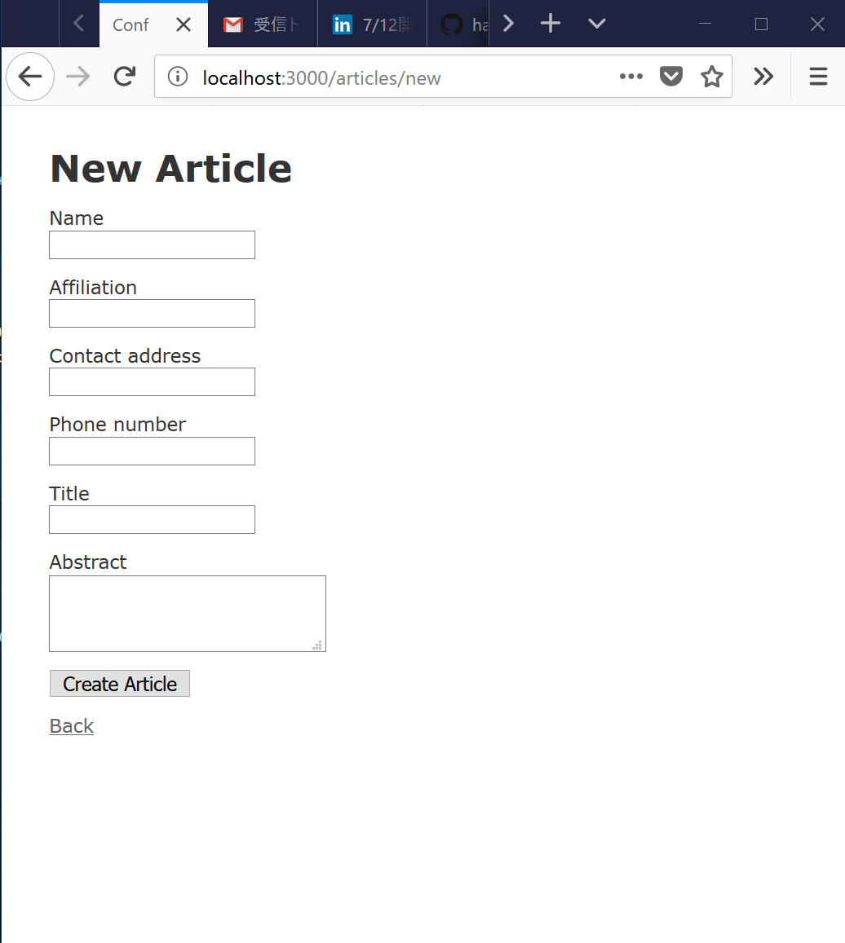

Screenshot: Validation is activated and shows error when the particular input is empty.

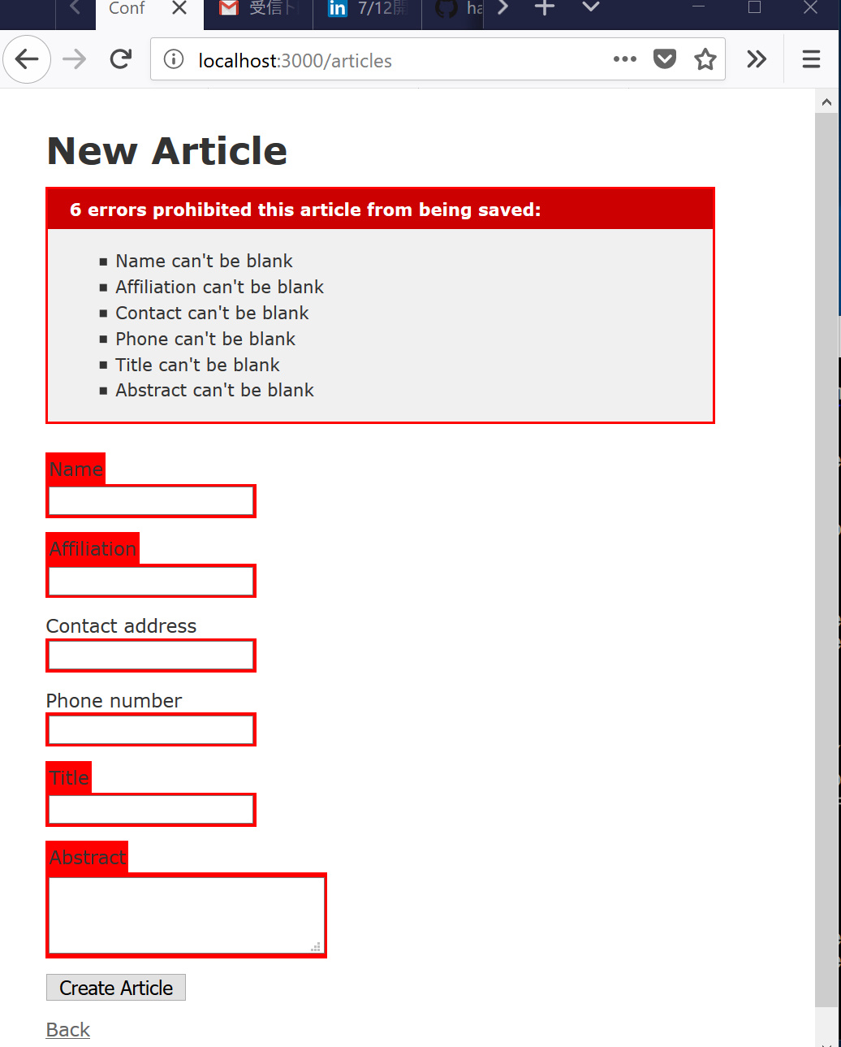

Screenshot: The validation is exactly active in editing page also.

